**DEVELOP A WEB APPLICATION USING NODE-RED**

|  |  |
| --- | --- |
| **Date** | 26-10-2022 |
| **Team ID** | PNT2022TMID18177 |
| **ProjectName** | **Project-IoT Based Safety Gadget For Child Safety Monitoring & Notification** |
| **MaximumMarks** | **2 Marks** |

STEPS:

* 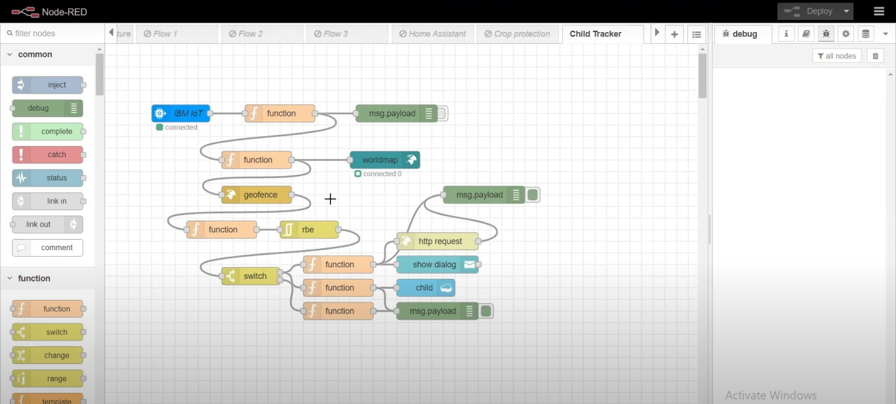Open Node-RED project
* Add code to get child location in python

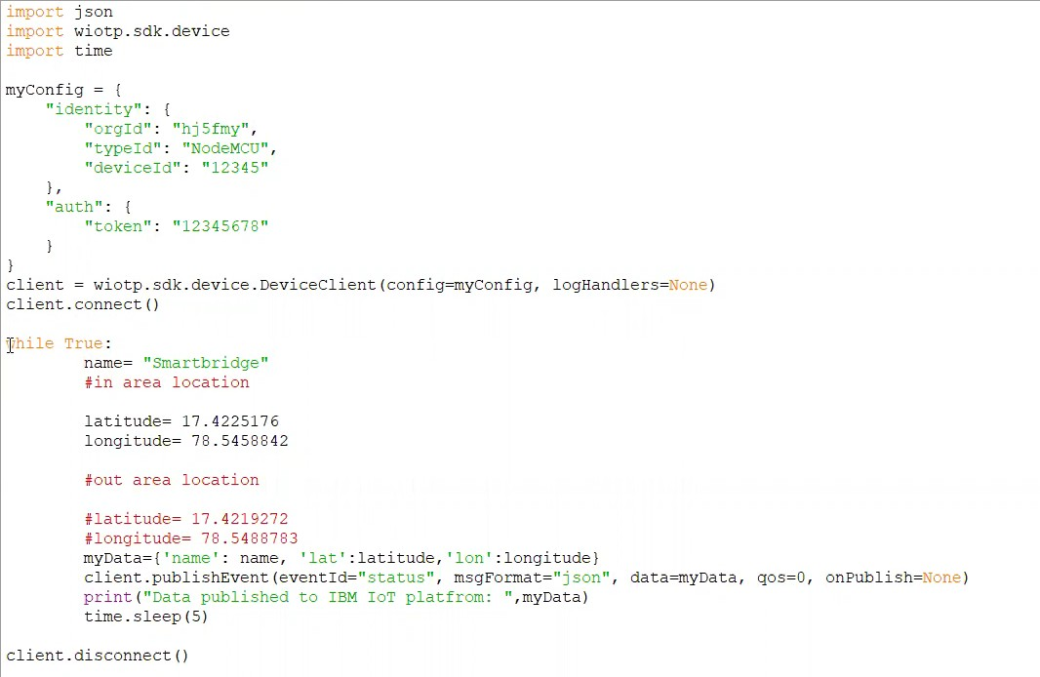

* 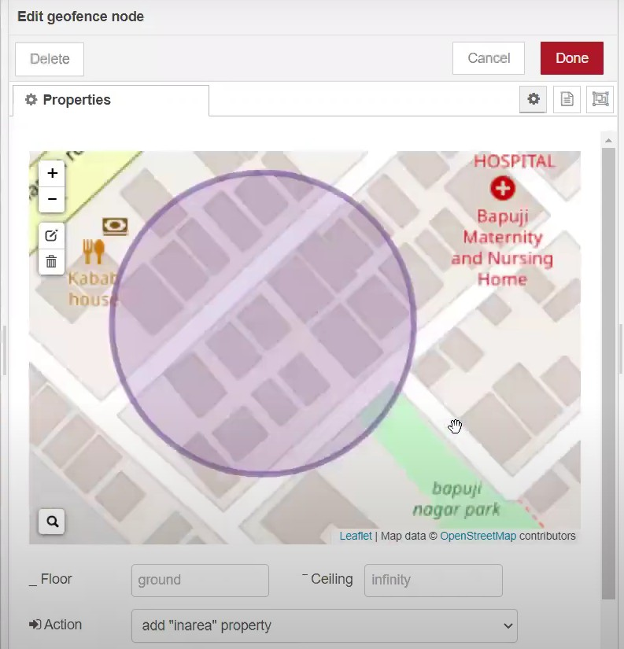Create a GeoFence
* 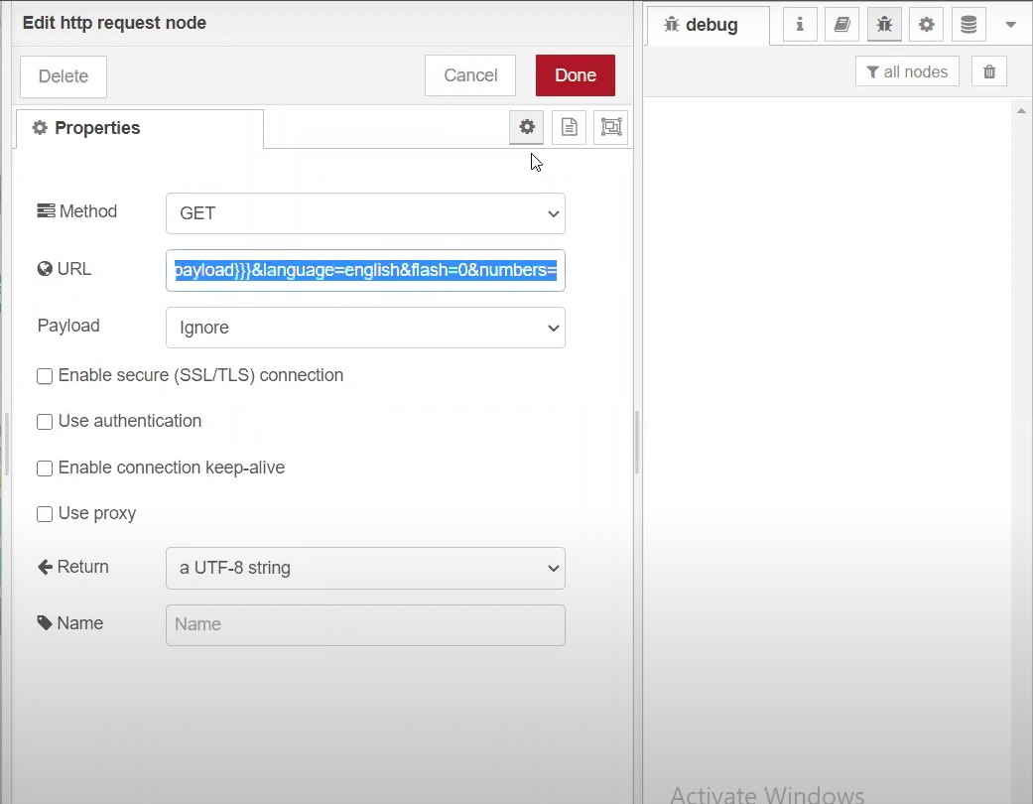Edit the HTTP Request URL
* Locate the child

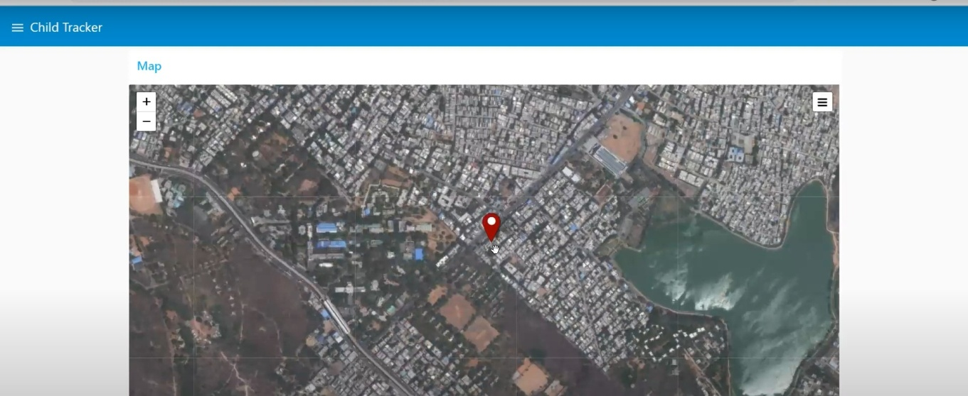

* 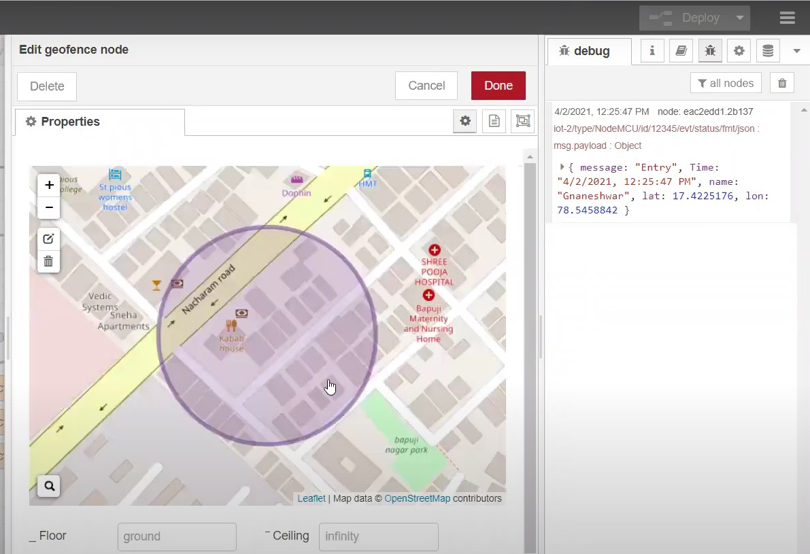Create the geofence node
* Python script sends request to IBM Cloud

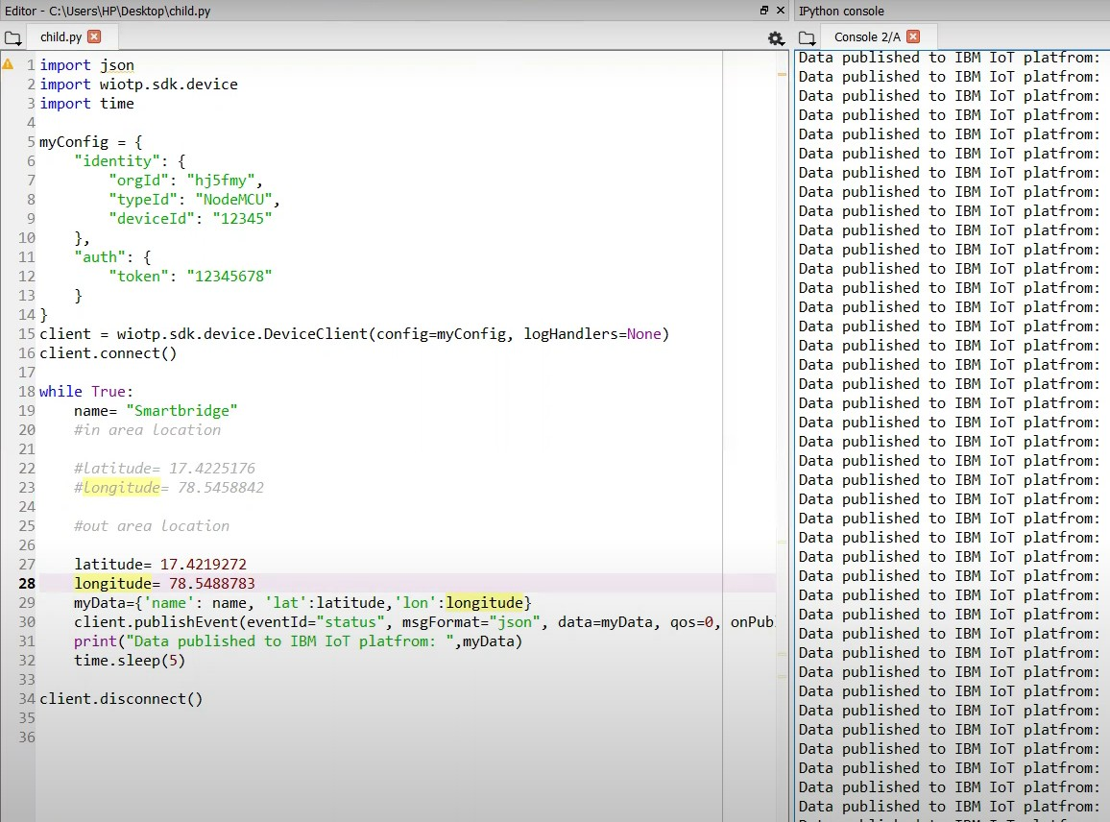

* 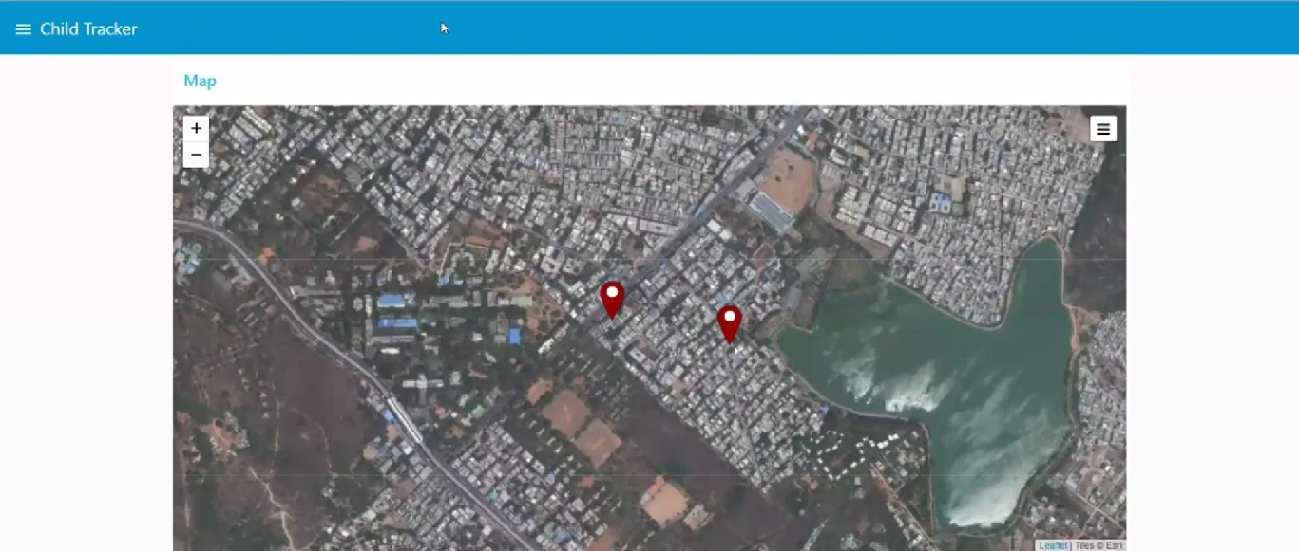After running the script, the web UI shows “Child is not in the particular area”